Excle Lab3 Assignmet

VLOOKUP

Q1. Use VLOOKUP to find the product names for each ProductID in the Orders worksheet.

Ans: =VLOOKUP(B2,B2:E7,2,FALSE)

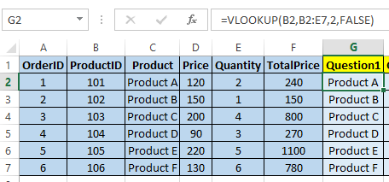

Q2. Use VLOOKUP to find the price for each ProductID in the Orders worksheet, then calculate the TotalPrice by multiplying the Quantity by the Product Price.

Ans: =VLOOKUP(B2,B2:F7,3,FALSE)

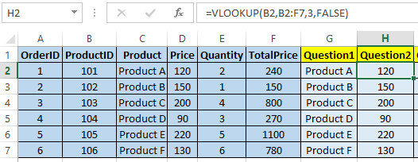

Q3. Use VLOOKUP to check if there are any ProductIDs in the Orders worksheet that do not exist in the Products worksheet.

Ans: =IF(ISNA(VLOOKUP(B2,B2:F7,1,FALSE)),"Yes","No")

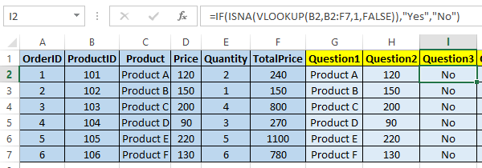

Q4. Assume a discount of 10% is given on all products. Use VLOOKUP to find the original price and then calculate the discounted price.

Ans: =VLOOKUP(B2,B2:F7,3,FALSE)\*0.9

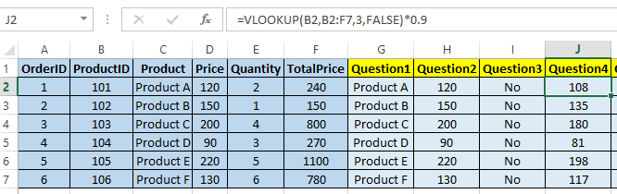

Q5. Use VLOOKUP to find the price for each ProductID and then calculate the order value. Find the maximum order value from the list.

Ans: =MAX(F2:F7)

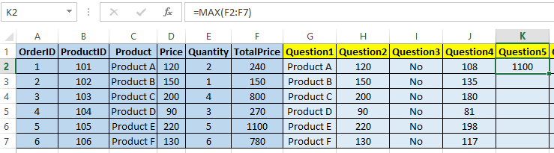

Q6. Use VLOOKUP to find out which products from the Products worksheet have not been ordered.

Ans: =IF(COUNTIF(B2:G7,E2)=0,"Not Ordered","Ordered")

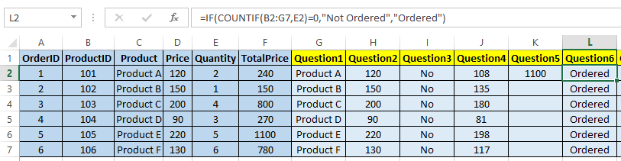

Q7. Use VLOOKUP to find the Product name and summarize the total quantity sold for each product.

Ans: =VLOOKUP(B2,B1:E7,2,FALSE)

